Playwright codes:
Npx playwright test –ui
Npx playwright test specific testfile name –headed
npx playwright test createCase.spec.ts --headed --project="chromium"
npx playwright test Agentforcetest.spec.ts --headed --project="firefox"
npx playwright test Agentforcestory582.spec.ts --headed --project="firefox"
npm i excel js

npx playwright codegen –o test testname
npx playwright codegen --viewport-size=900,600
npx playwright show- trace trace.zip
utility file: https://trace.playwright.dev/?trace upload trace file here
Reporting with allure
npx playwright test example.spec.ts --reporter=line,allure-playwright
allure generate ./allure-results --clean(clean is optional)
allure open ./allure-report

810173 VSP One Block 20 Series
Description: Customer reached out regarding performance issues occurring during service case installations. The problem is affecting select users in their production environment and is beginning to interfere with daily operations. This case aims to assess the situation and provide the necessary assistance.
Yes,critical work blocked ,Most

Npx playwright codegen baseurl :is used to record all the actions & provide the code for all the actions which we did manually.
To debug
Npx playwright test specific testfile name –debug
if anything is failed due to locators issue while debugging we can select the loactors which recommend by Playwright. Select next to record one square arrow to generate new locators.
Await page.pause();
The page.pause() method in Playwright halts script execution and opens the Playwright Inspector, allowing you to interact with the browser, inspect elements, and step through code for debugging.
To see the report: playwright reportindex html right click copy the path keep it in new window

allure generate. /allure-results-o./allure-report –clean

npx playwright codegen --project=”firefox”
error: unknown option --project=’firefox’
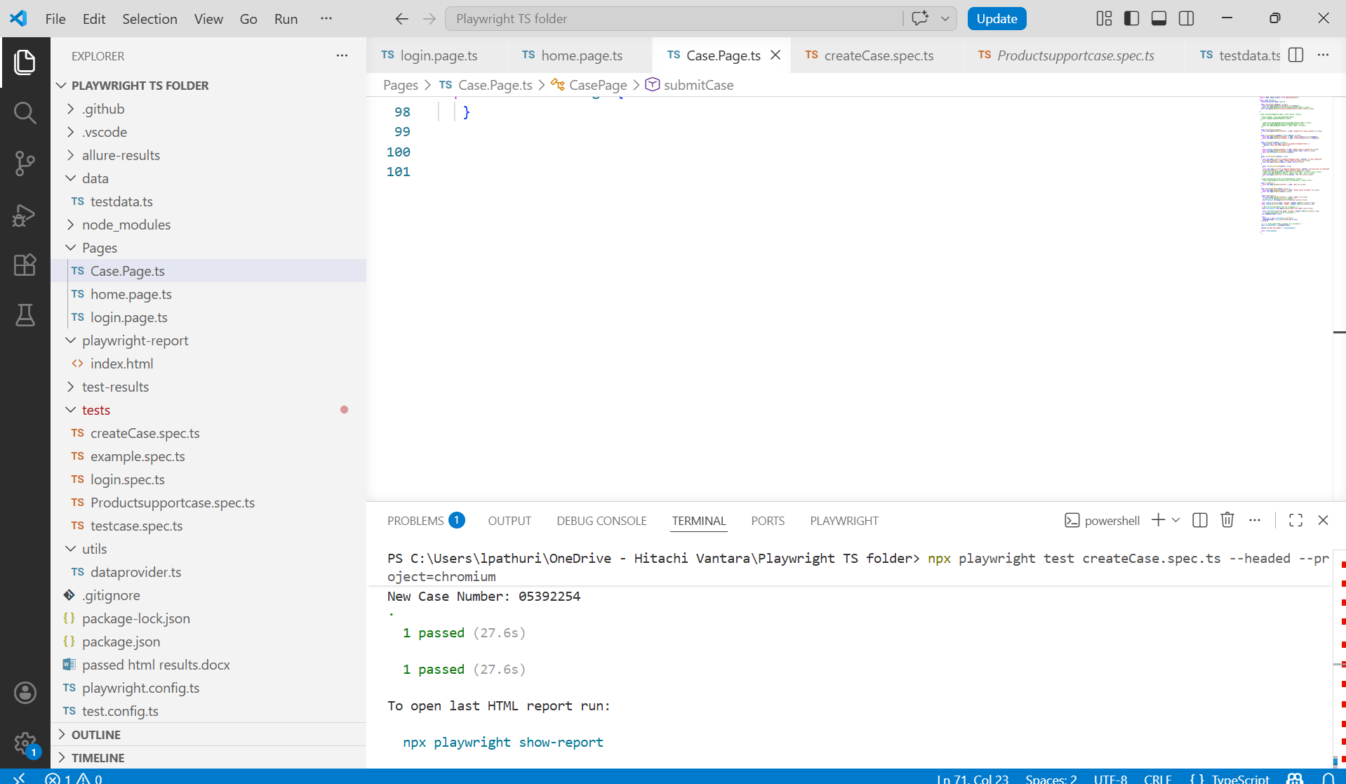

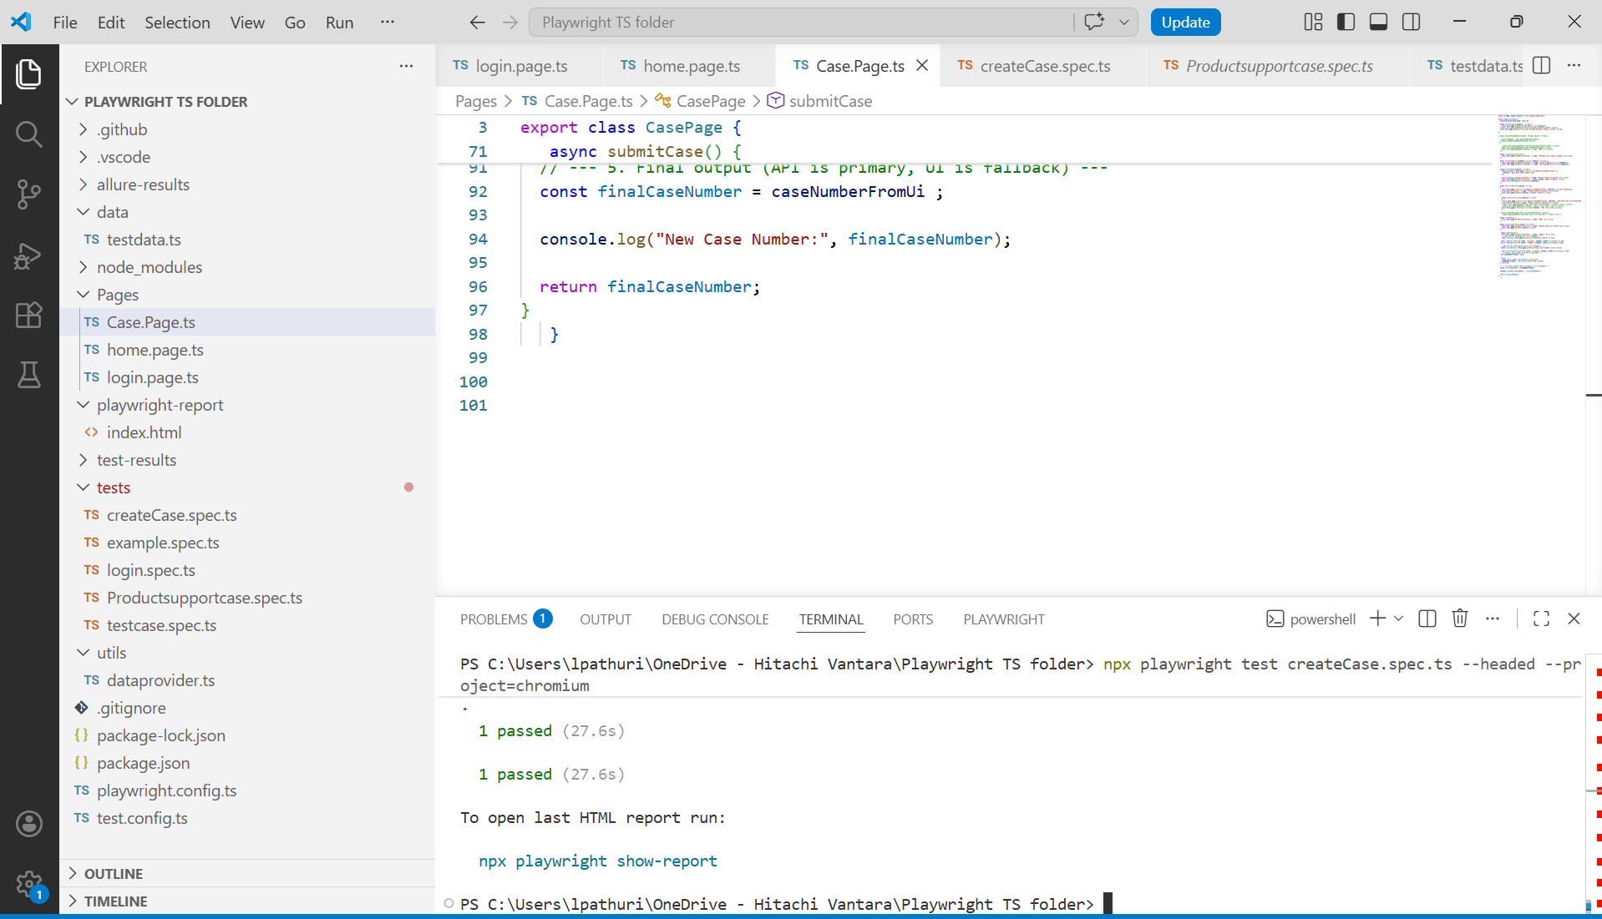
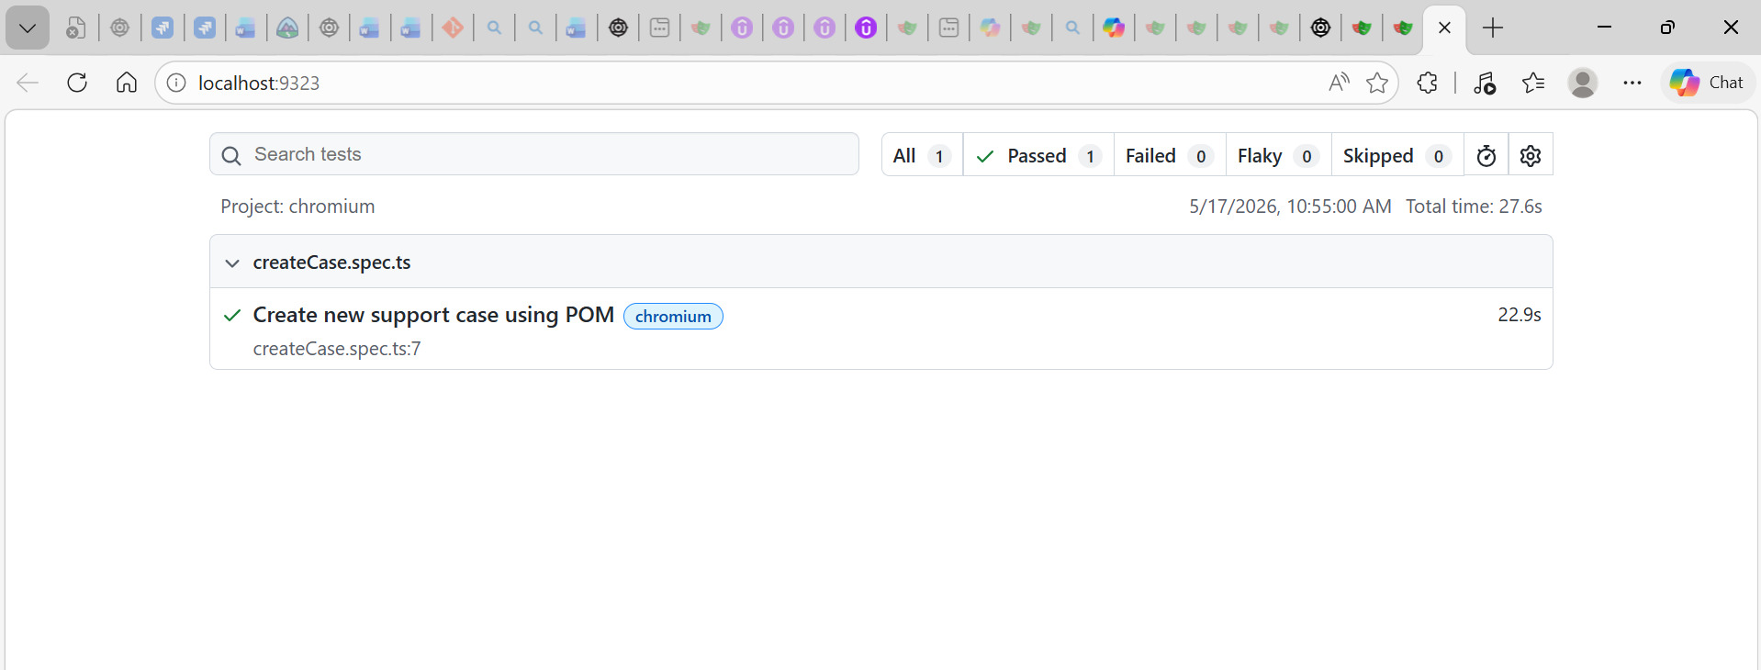
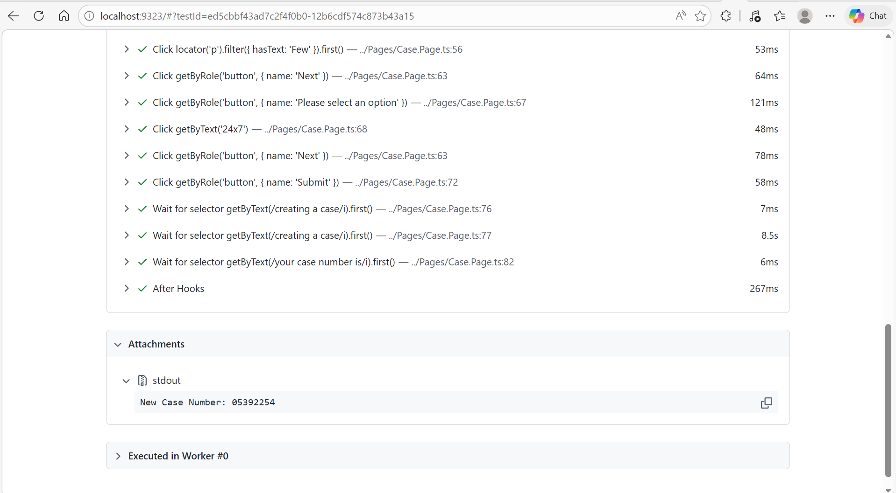

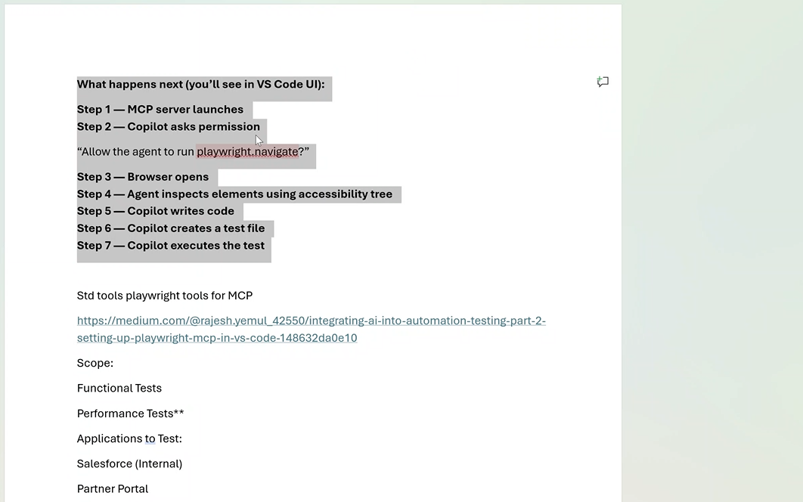
npx playwright test AgentforceCaseCreate.spec.ts --headed --project="chromium"

https://auth-stage.hitachivantara.com/samlp/v1GfMFlUp1oUeOzOWvkHYgNEF2S2C9OA?SAMLRequest=fVLbbhshFPyVFe97Aaf2GtmWXDtuHDmx5Uuq9qVi2YOXZBcosE7Sry9dN2n6kEhISMOZGWZ0Ro41taHT1ldqCz9bcD56amrlaPcwRq1VVDMnHVWsAUc9p7vpzYqSJKPGaq%2B5rtEbyscM5hxYL7VC0XI%2BRj%2FynFx8Ggy4KPpc5EUx7IsiG2COBc5IwQAPhqKXlaJHUHQH1gXmGAWhQHeuhaVynikfoIz04ywcvMcXFOeU5N9RNA9ppGK%2BY1XeG0fTlIWocaAdIamkZ7ySpyDBLEu4btIudXrCX8TNoj4YrA%2Bw%2FrX%2Benq4%2Bna8vVyQHZkN11MUTV%2BCzLRybQN2B%2FYkORy2q39WhlmvwL7v1n9%2Bul71hvfztNFlW0NiKtN9IXXnm8SMuw596N2b68vtHaBo87f2z1KVUh0%2Fbrw4Dzl6td9v4s16t0eT0R9p2jVoJ6%2FCo%2FQtPDovxm0QXM43upb8OVpo2zD%2Fvh9OcIfIMhbdKG2VM8ClkFCGzupaP84sMA9j5G0LKJ2cTf9fwMlv&RelayState=https%3A%2F%2Fpartner-stage.hitachivantara.com%2Fcontent%2Fdam%2Fpartner%2Flibrary%2F2023%2Fwhats-new-with-vsp-one-object.pptx

2. https://partner-stage.hitachivantara.com/content/dam/partner/library/2023/maximizing-hdps-performance-vsp-e590-with-25g-iscsi.pdf

VSP Gx00 and VSP Fx00

